**Coding Interview**

1. *\*\*\*Focus on completing yours tasks within the given duration, alternate technology options are provided\*\*\**
2. Create a spring boot application using Maven in Eclipse/ Intellij
3. Create a data structure Employee and Department, Sample Given Below

{

"departments": [

{

"id": "dept01",

"name": "Human Resources",

"location": "Building A",

"employees": [

{

"id": "emp001",

"name": "Alice Smith",

"email": "alice.smith@example.com",

"position": "Recruiter",

"salary": 60000

},

{

"id": "emp003",

"name": "Charlie Brown",

"email": "charlie.brown@example.com",

"position": "HR Assistant",

"salary": 40000

}

]

},

{

"id": "dept02",

"name": "Engineering",

"location": "Building B",

"employees": [

{

"id": "emp002",

"name": "Bob Johnson",

"email": "bob.johnson@example.com",

"position": "Software Engineer",

"salary": 80000

},

{

"id": "emp004",

"name": "Diana Prince",

"email": "diana.prince@example.com",

"position": "System Architect",

"salary": 90000

}

]

}

]

}

1. Rest API for the following
   1. Get method to get all employee
   2. Get method to get all department.
   3. Get employee in a department
   4. Add new Employee in a department.
   5. Delete an employee in a department.
2. Usage any database of your choice In-memory like H2 is also fine, if you cannot use a database then In memory json is fine but resources who demonstrate with DB will be preferred.
3. Create Jasper Report PDF report showing Employees in each department. Each department should be one page in the PDF.
4. Demonstrate usage Controller, Service, DTO and DAO/ Repository
5. Demonstrate Transaction Management
6. Demonstrate usage of Map and Lists
7. Use front end framework preferred Angular with responsive framework like Bootstrap 5+, If not proficient In angular use plain HTMl/JavaScript /CSS is also sufficient. (Candidates using Angular are rated higher) , use VSCODE IDE
   1. Text box accepting Department Id
   2. Resulting a Table of Employees
   3. Click on an Employee takes me to a screen with Employee information.
   4. Amend or delete an employee.
8. Please create a web page using HTML CSS to create the following cards no JavaScript is required, You can use any images of you choice . use VSCODE IDE

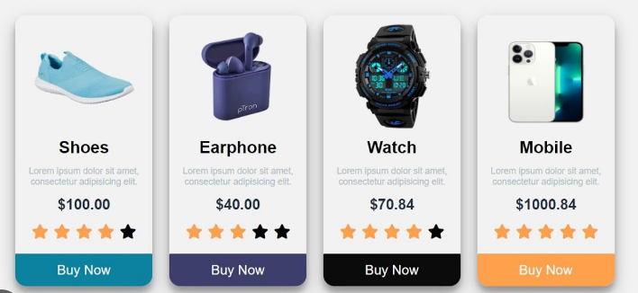

1. You can demonstrate the final output on your PC.